
Texas A&M University-Commerce
Ticketrak Refund Process

STEP 01:

Go to Ticketrak Portal and Login with SSO:
URL: Ticketrak
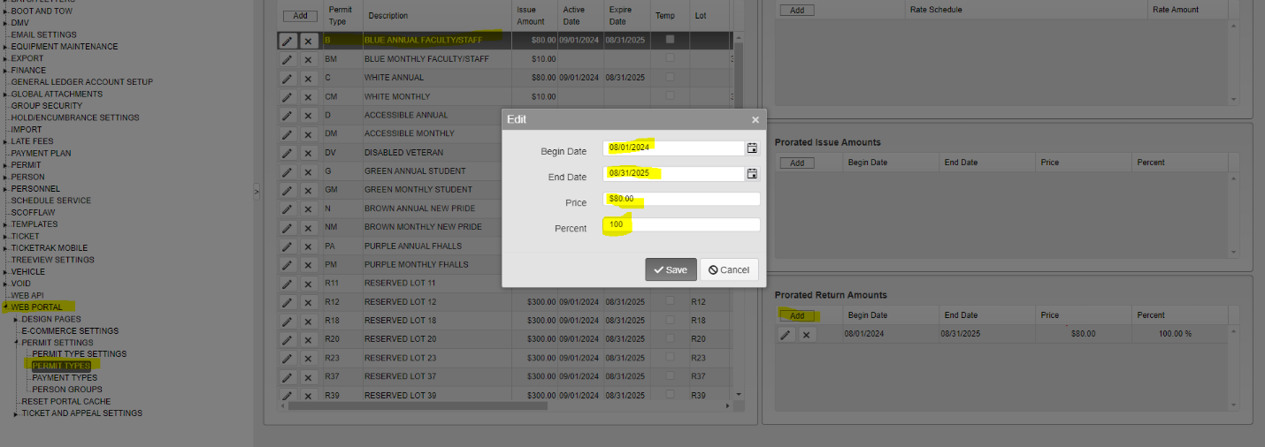
ADMIN > SYSTEM SETTINGS > PERMIT SETTINGS > WEB PORTAL > PERMIT TYPES

In the permit type, select the permit you want to refund. When you select the permit type example, BLUE ANNUAL FACULTY STAFF
- CLICK ON THE BLUE ANNUAL FACULTY STAFF PERMIT in the middle box
- Click on the ADD button in the PRORATED RETURN AMOUNT box
- Fill the date range August 01, 2024 to August 31, 2025 (FY 24-25)
- Percent is always 100.00 unless there is a partial refund.
- SAVE and exit out.

STEP 02:
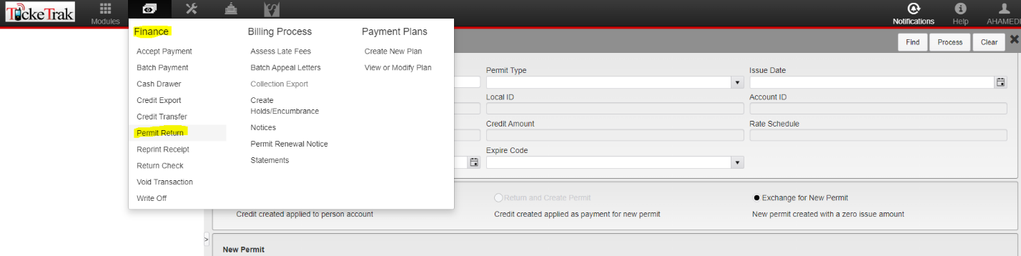
- Go to the Finance Module at the top right of the Home Page.

- FINANCE > PERMIT RETURN > (Enter Permit Number you want to return) < FIND

- Check the details and double-check that the Permit and Amount are correct.
- Make sure the RETURN ONLY box is checked,
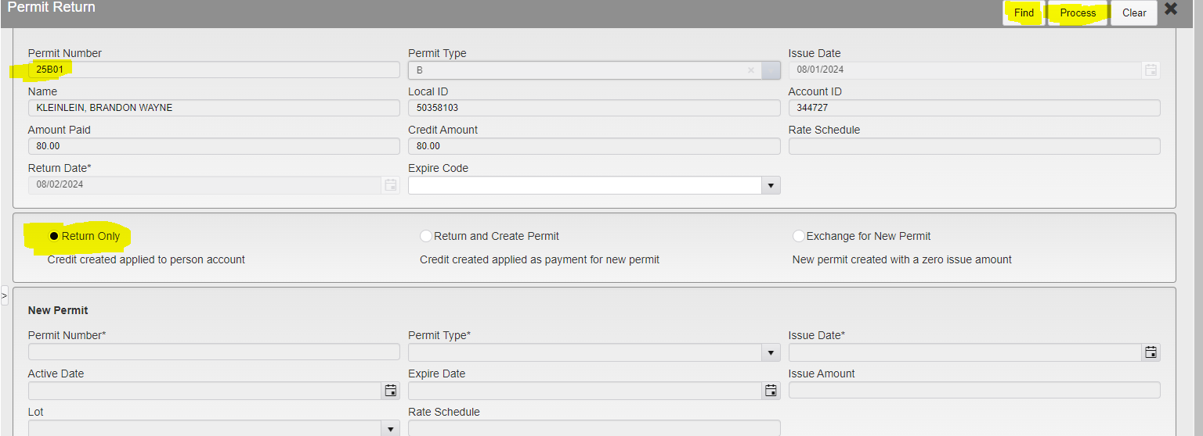
- Leave Expire Code blank

- Process to Complete

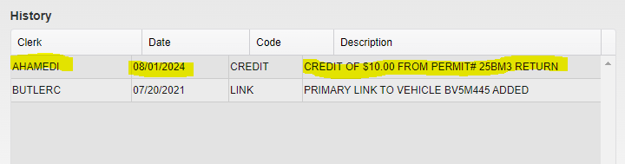
You can check if the return is successful by looking for the History box under the permit list tied with a person.

